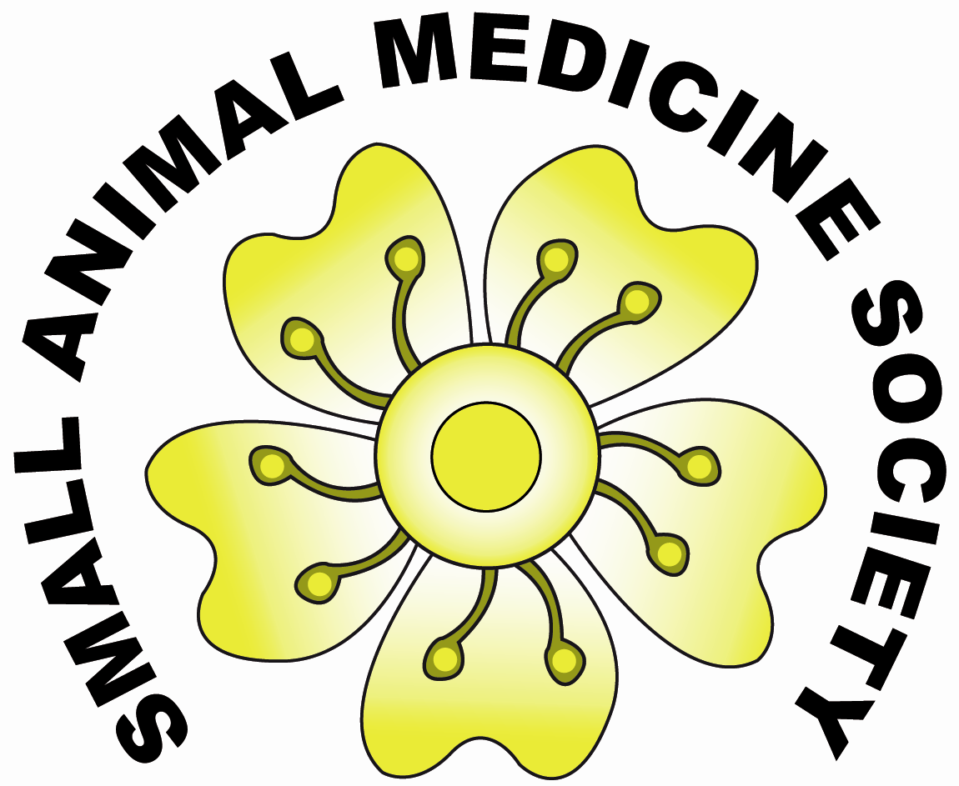

Registration for SAMSoc Satellite Meeting 7th April 2010

Name
Address

Email
Please make sure this is legible
and in the correct case etc.

I wish to register for the Small Animal Medicine Society pre-BSAVA satellite meeting on 7th April 2010.

Please select one of the following:
(Please note it is more economical to become a member of SAMSoc if you are attending the meeting!)

□ I am already a member of SAMSoc- registration for meeting £65

□ I am NOT a member of SAMSoc, - registration for meeting only £95

□ I am NOT a member of SAMSoc, -registration for meeting AND membership of society £90

Lunch is provided – IMPORTANT Deadline for catering numbers is 15th MARCH 2010 (lunch will not be included in the price if payment is received beyond this date!)

Please indicate if you are a vegetarian: Yes/No

All cheques should be made payable to ‘SAMSoc’.
Receipts will be sent by email where possible.

Signature………………………………….. Date / /

Please return this completed form with payment to:
Yvonne McGrotty
13 Lochmaben Road
Gartcosh
Glasgow G69 8LA

