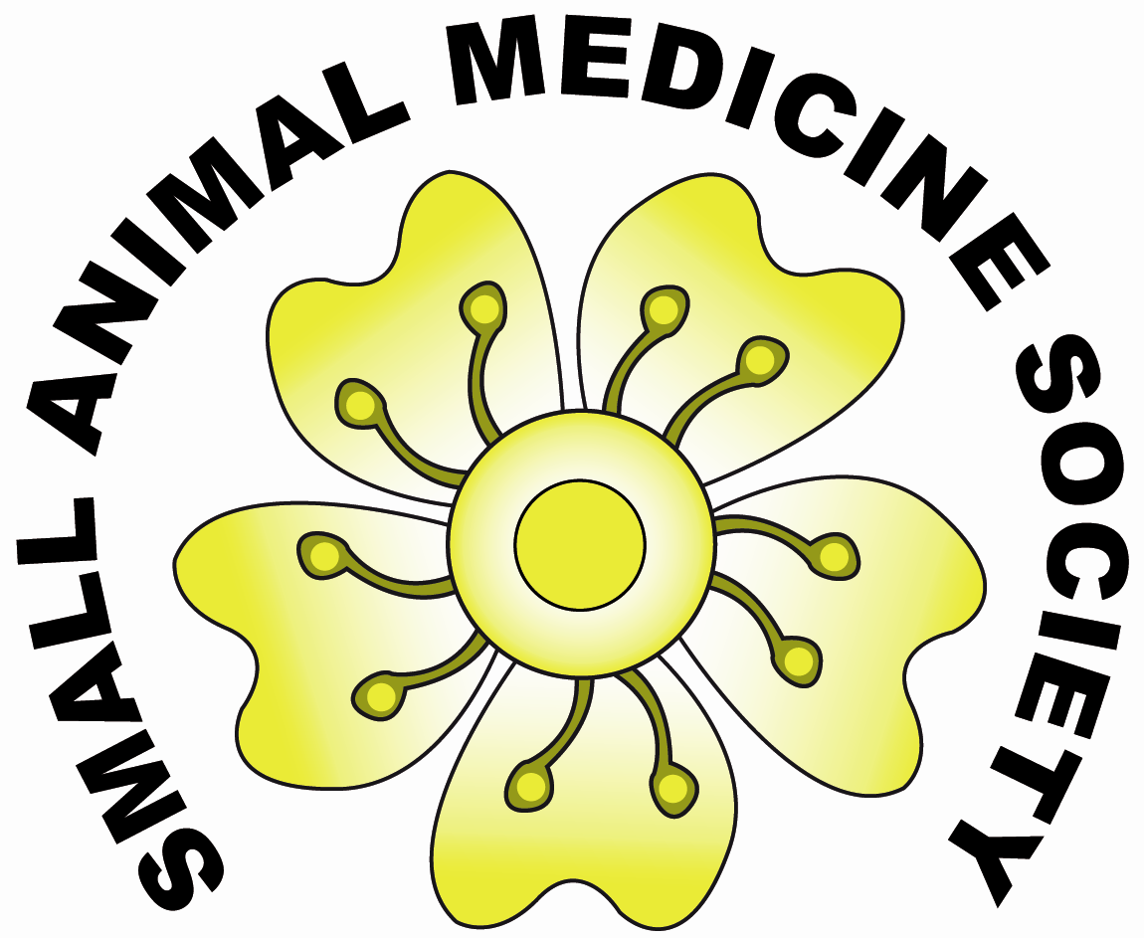

Pre-BSAVA Satellite Meeting - Wednesday April 7th 2010, Hall 10, ICC, Birmingham

8.30 – 9am | Registration
9 – 9.45 | Epilepsy: when the (usual) drugs don’t work... | Dr Holger Volk DrMedVet PhD DipECVN MRCVS (RVC, UK-Germany)
9.55 – 10.40 | Antimicrobial usage in companion animal practice: facts and moral dilemmas | Dr Susan Dawson BVMS PhD MRCVS (University of Liverpool, UK)
10.50–11.20 | Break
11.20-12.05 | Case Reports – sponsored by Vetoquinol
12.05 – 1.00 | Venous thromboembolism: learning from a human perspective | Dr Nandan Gautam MA, BM ChB, MRCP DICM. Consultant in medicine and critical care. Member of the NICE venous thromboembolism prevention committee ( Birmingham UK)
1.00 -2.30 | Lunch (till 2.00 for those attending lunch-time session)
2.00-2.30 | How to write a successful CertSAM casebook? (optional) | Jon Wray BVSc DSAM CertVC MRCVS (Dick White Referrals, UK)
2.30-3.15 | Controversies surrounding treatment of aortic thromboembolism | Dr Matt Beal DVM DipACVECC  (Michigan State University, USA)
3.25-3.35 | Presentation of the first “SAMSoc Travel Scholarship”
3.35-4.20 | Feline Acromegaly: separating facts from assumptions | Stijn Niessen DVM DipECVIM-CA MRCVS (RVC, UK-Netherlands)
4.30-5pm | AGM and presentation “best case report award” sponsored by Vetoquinol

Satellite meeting fees (lunch is included if you register before March15th 2010)
Members £65, Non members £95. SAMSOC annual membership - £25

If you are interested in joining the society and/ or attending the meeting contact yvonnemcgrotty@hotmail.com
or iab@vetspecialists.co.uk. Details can also be found on the SAMSOC webpage (log onto www.vetsurgeon.org).

