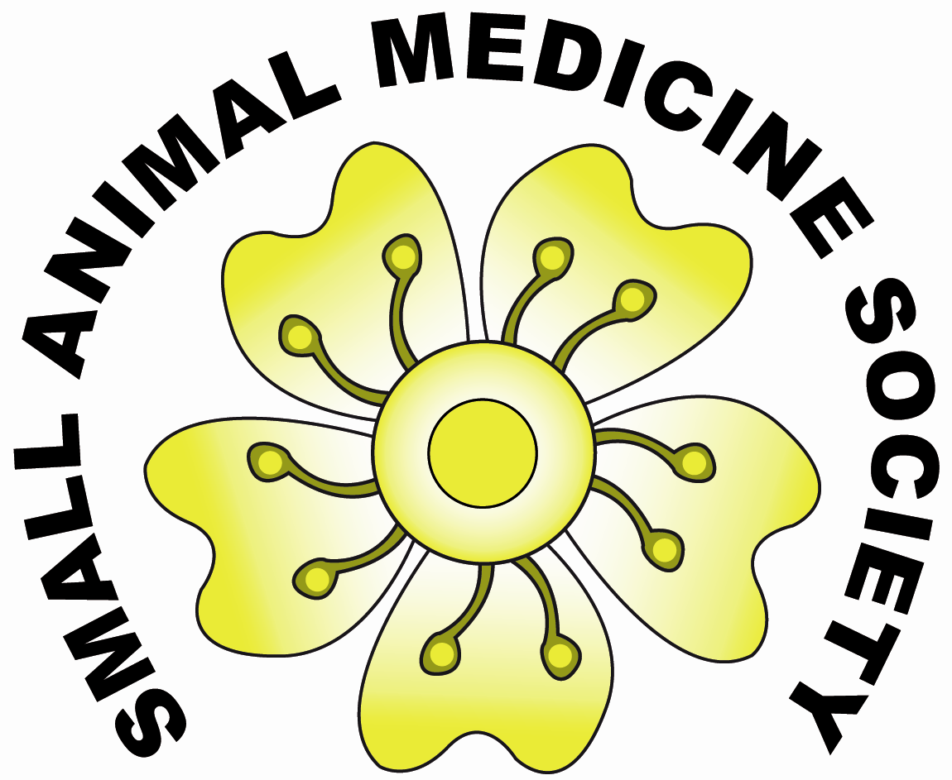

Registration for SAMSoc Satellite Meeting 1st April 2009

Name
Address

Email
Please make sure this is legible
and in the correct case etc.

I wish to register for the Small Animal Medicine Society pre-BSAVA satellite meeting on 1st April 2009.

Please select one of the following: (Please note it is more economical to become a member of SAMSoc if you are attending the meeting!)

□ I am already a member of SAMSoc- registration for meeting £65

□ I am NOT a member of SAMSoc, - registration for meeting only £95

□ I am NOT a member of SAMSoc, -registration for meeting AND membership of society £90

Lunch is provided – IMPORTANT Deadline for catering is 10th MARCH 2009.
Please state if you are a vegetarian: Vegetarian? Yes/No (delete as appropriate)

All cheques should be made payable to ‘SAMSoc’.
Receipts will be sent by email where possible.

Signature………………………………….. Date / /

Please return this completed form with payment to:
Yvonne McGrotty
Veterinary Internal Medicine Referrals
C/o Broadleys Veterinary Hospital
Craig Leith Road
Stirling, FK7 7LE

